

Table of Contents

1. Introduction 2

1.1 Purpose 2

1.2 Scope 2

2. System Overview 2

2.1 System Architecture 2

2.2 System Components 2

3. Data Management 2

3.1 Data Sourcing 2

3.2 ETL Process 2

4. Data Modelling 3

4.1 Table description 3

4.2 Schema Design 4

5. Visualization & User Interface 4

5.1 Layout 4

5.2 Features & Functionalities 5

6. Technical Requirements 6

6.1 Software & Tools 6

6.2 Hardware Requirements 6

7. Conclusion 6

# 1. Introduction

## 1.1 Purpose

This document outlines the design and implementation strategy for the capstone project, which aims to develop a comprehensive data analytics system for hospital management. The design document serves as a blueprint, ensuring all stakeholders understand the project's scope, system architecture, data management strategies, and technical requirements.

## 1.2 Scope

The project focuses on creating a system for efficient data handling and analysis in a hospital setting. It includes data sourcing, storage, ETL (Extract, Transform, Load) processes, data modelling, and visualization. The system will not cover aspects like real-time patient monitoring or electronic health record integration.

# 2. System Overview

## 2.1 System Architecture

* Data Sourcing: Patient records, treatment data, hospital management data.
* Data Storage: Cloud-based SQL database.
* ETL Process: Extraction from various hospital systems, transformation to standardize formats, and loading into the database.
* Data Modelling: Entity-Relationship modelling.
* Visualization: Interactive dashboards using Tableau.

## 2.2 System Components

* User Interface: Web-based dashboard for data visualization.
* Backend Processing: ETL scripts and data cleaning routines.
* Database: Structured storage in an Excel worksheet.

# 3. Data Management

## 3.1 Data Sourcing

* Patient Records: Data from the hospital's patient management system.
* Treatment Data: Information from treatment logs and schedules.
* Management Data: Administrative and operational data from hospital management systems.

## 3.2 ETL Process

* Extract: Automated scripts to pull data from various sources.
* Transform: Data cleaning and formatting to ensure consistency.
* Load: Storing the cleaned data into the SQL database.

# 4. Data Modelling

## 4.1 Table description

|  |  |  |
| --- | --- | --- |
| Table_name | Columns | Data_type |
| ID | Hospital_id(P.K) | Number |
|  | Patient_ID(P.K) | Number |
|  | Visit_ID(P.K) | Number |

|  |  |  |
| --- | --- | --- |
| Table_name | Columns | Data_type |
| Hospital_info | Admission_Type | Text |
|  | Department_Name | Text |
|  | Diagnosis_code | Number |
|  | Diagnosis_Description | Text |
|  | Hospital | Text |
|  | Hospital_ID(F.K) | Number |
|  | Satisfaction_score | Number |

|  |  |  |
| --- | --- | --- |
| Table_name | Columns | Data_type |
| Admission_info | Admission_type | Text |
|  | Arrival_Time | Time |
|  | Attending_time | Time |
|  | Date_of_admission | Date |
|  | Department_name | Text |
|  | Medication | Text |
|  | Patient_id(FK) | Number |
|  | Visit_ID(F.K) | Number |
|  | Waiting_time | Time |

|  |  |  |
| --- | --- | --- |
| Table_name | Columns | Data_type |
| Patient_info | Admission_type | Text |
|  | Age | Time |
|  | Amount_paid | Time |
|  | Blood_type | Date |
|  | City | Text |
|  | Department_name | Text |
|  | Gender | Number |
|  | Hospital | Number |
|  | Insurance_provider | Time |
|  | Patient_ID(F.K) | Number |
|  | Total_Amount | Number |

|  |  |  |
| --- | --- | --- |
| Table_name | Columns | Data_type |
| Insurance | Insurance_provider | Text |
|  | Patient_id(F.K) | Number |
|  | Total_amount | Number |

## 4.2 Schema Design

* ID: Stores all the primary keys
* Hospital_info: Stores the data related to the hospital
* Admission_info: It stores the data related to the admission of the patients
* Patients_info: Stores patient demographic details.
* Insurance: Stores details of insurance related data.

# 5. Visualization & User Interface

## 5.1 Layout

* Dashboard Layout: Divided into sections for patient statistics, treatment outcomes, and hospital operations.
* Interactive Elements: Filters for date ranges, patient demographics, and treatment types.

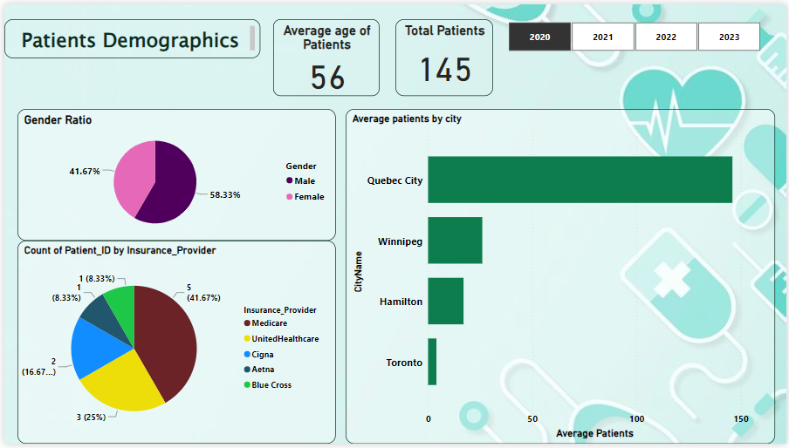

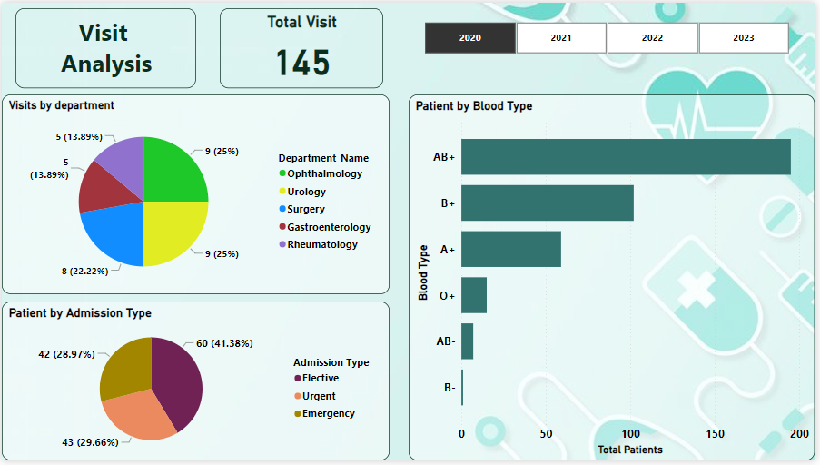

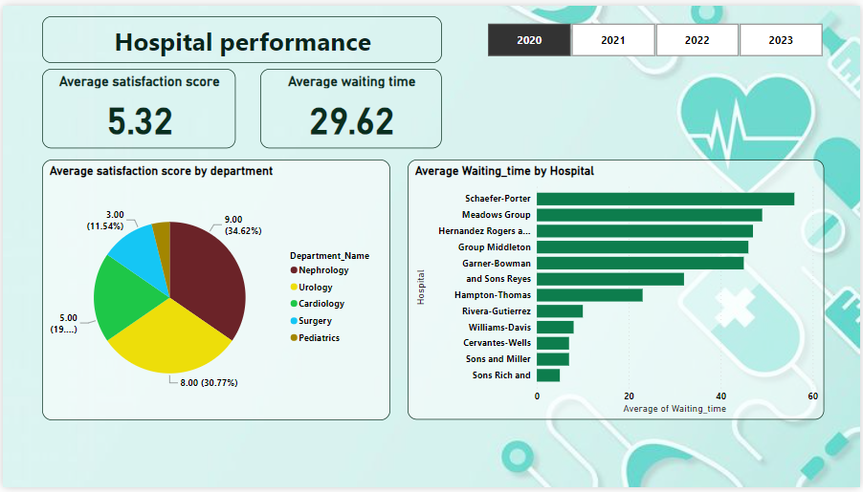

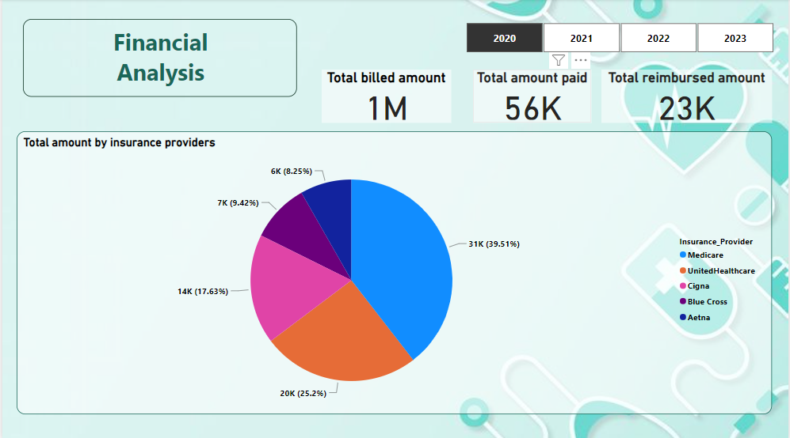

## 5.2 Features & Functionalities

* Interactive Elements: Dropdowns, date pickers.
* Filter & Search Options: Search by patient ID, treatment type.
* Navigation: Menu bar with links to different sections of the dashboard.

# 6. Technical Requirements

## 6.1 Software & Tools

* MS Excel: For data storage.
* Power BI: For data visualization.
* Python: For ETL scripts and data processing, cleaning and sorting the data.

## 6.2 Hardware Requirements

* Computational Requirements: Minimum 4 vCPUs, 16GB RAM.

# 7. Conclusion

This design document provides a comprehensive plan for developing a hospital management data analytics system. Future enhancements could include real-time data processing and integration with electronic health records.